

Content Strategy Population

Aim & Scope  Provide step-by-step instructions for completing the content strategy template with SEO data and strategic prioritisation.. | Background  This guide combines keyword research, competitor SERP analysis, traffic potential data, and search console performance metrics to ensure content topics are strategically prioritised, business-aligned, and optimised for search visibility and ranking success.

Responsibilities

Project manager  Responsible for planning the content ideas using the template and scheduling the tasks in Asana. | SEO Copywriting  Responsible for drafting the content strategy and content. | Reviewer  Reviewing the content ideas to ensure relevancy, alignment with business goals and search demand.
Prerequisites & TOC

Table of contents  Content Strategy SOP  Introduction  Process for populating the template  Content title title, type and description columns  Primary keyword columns  SERPs - Columns  Supporting content & delivery status  Ask for your topics to be reviewed  How to find ideas | Important links:  - Content strategy + ideation template  - Keyword research for content creation  - Keyword research sheet - template  - Surfer logins  - Ahrefs logins  - Tools required: Ahrefs, Google Search Console, Keyword Research Template, SurferSEO  - If a content audit has been completed, use it.

Process For Populating The Template

Content Title, Type and Description Columns
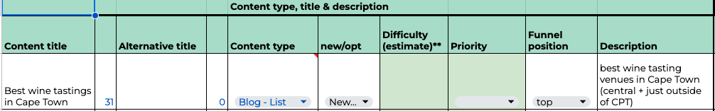

Title
Write the title/h1 of your blog post or landing page in the content title column.
Provide an alternative title if necessary.

Content type
Use the dropdown to select the type of post or landing page.

New/opt
Use the dropdown to state whether this is an optimisation or a new piece of content.

Difficulty estimate
Leave this out until you have populated the primary keyword and SERPs columns.
Thereafter, estimate the difficulty of the task from an SEO/ranking perspective: low, medium or high.

Priority
Leave this out until you have populated the primary keyword and SERPs columns.
Thereafter, using the dropdown, select low, medium, or high to give the reviewer and client an idea of the priority compared to other topics in your list, taking into account the difficulty.

Keyword Focus & Research Columns
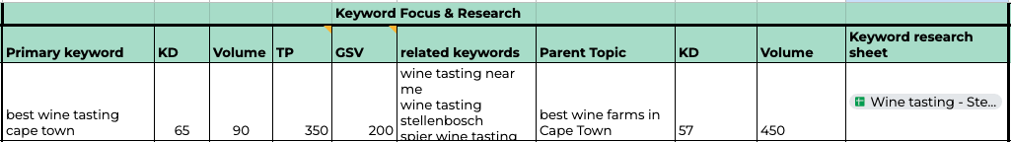

Primary Keyword
State the primary target keyword for your post. This should be the most focused variation of your keyword.

- For example, if you are writing a blog post on the 10 Best Wine Tastings in Cape Town, your post may rank for “wine tasting” or “wine farms”; however, your focus keyword should be “best wine tastings in Cape Town”.

Ensure you follow the keyword research for content creation SOP and brainstorm a list of relevant keywords related to the content. Export the overview, matching, questions, related and the SERP data for your primary target keyword.

KD to GSV Columns
Add the keyword difficulty (KD), volume, traffic potential (TP), and global search volume (GSV) data for your selected primary keyword from your completed keyword research.

Related Keywords
Based on your keyword research, add keywords related to your primary keyword that you may also target based on the scope of the content.

- For example, for a post covering the best wine tastings in Cape Town, your post may rank for “wine tasting” + “location” (i.e, Stellenbosch) depending on the venues you choose to feature and their locations. By the same notion, your post may also rank for the venues you feature, such as “venue + wine tasting” (i.e, Groot Constantia).

Parent Topic
Your primary keyword will be associated with a parent topic in Ahrefs. Add the parent topic here.

KD - Keyword Difficulty (for Parent Topic)
Add the keyword difficulty for the parent topic here.
You may need to search the parent topic/keyword in Ahrefs to find its keyword difficulty.

Volume - Monthly Search Volume (for Parent Topic)
Add the search volume for the parent topic here.
The parent topic volume can be found in the SERP tab in your keyword research sheet.

Keyword Research Sheet
Add a link to your keyword research sheet.

SERPs Columns
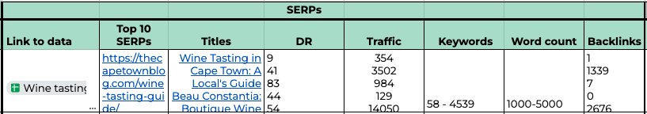

Link to Data
Add a link to the SERP tab within your keyword research sheet.
During keyword research, you would have exported the SERP for your primary keyword.

Top 10 SERPs
Copy and paste the links to the top 10 organic search results.
There will be a lot of search results in the SERP tab, such as local pack results.

You need to look for or apply a filter to include only “organic” and “Organic, Thumbnail” under the column “type” in the SERPs sheet.

Here is an example.

Titles to Backlinks Columns
Add the titles, DR, traffic, keywords, backlinks, and word count of the top 10 search results by applying the same logic of only considering the top 10 organic search results above.

For word count, you can provide the lowest word count and the highest word count (range). This word count feature from Ahrefs tends to be very inaccurate in most cases, so you may wish to click on the links to the results to double-check.

Current Rankings Columns
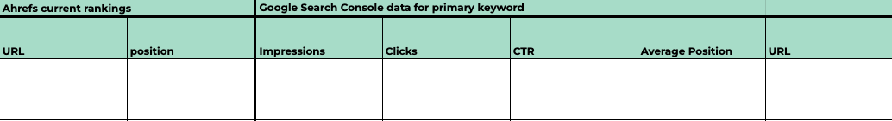

Ahrefs

Paste your primary keyword into the keywords explorer.

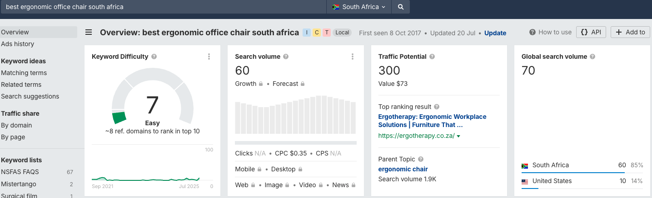

Navigate to the bottom of the page and click “Show more” to reveal the long list of domains ranking for the keyword.

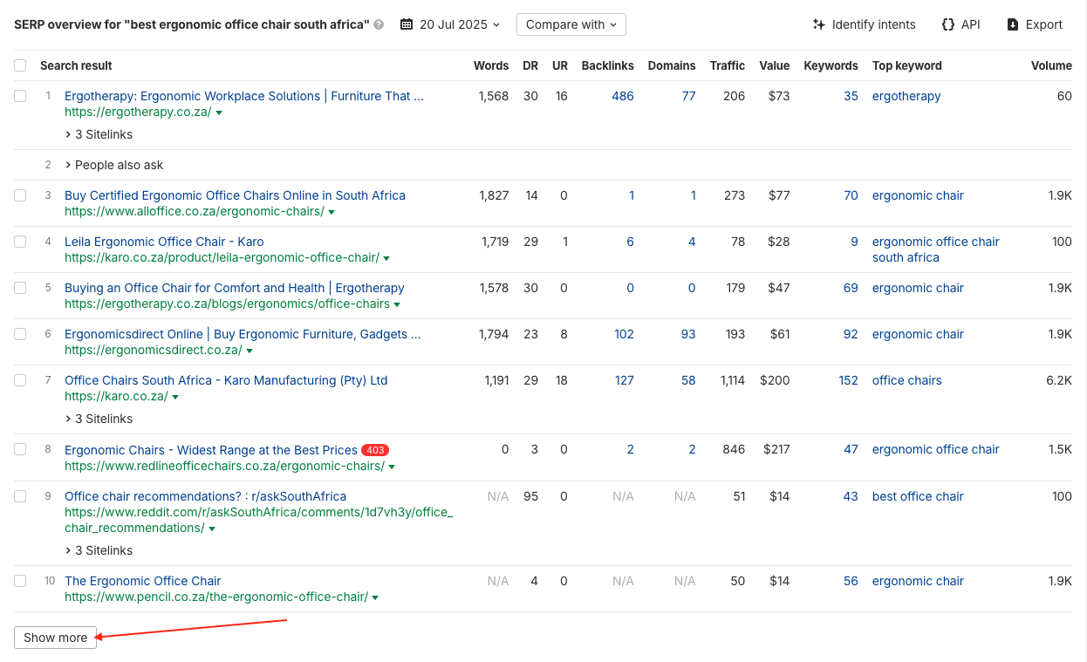

Use the “CTRL + F / Command + F” keyboard shortcut and type/paste the domain.

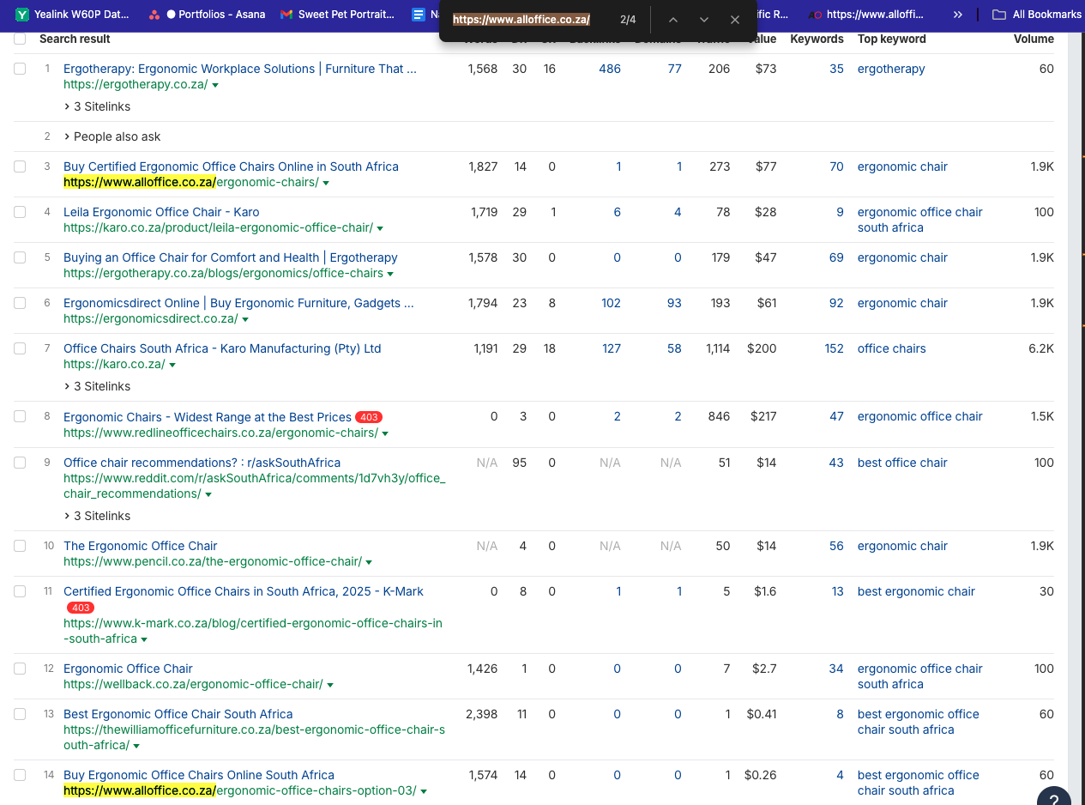

Copy the URL and fill in the ranking position

Google Search Console

Set your desired date range and the region you’re targeting (i.e SA / US).
Click on filter > query > exact query.
Enter the primary keyword and click Apply.

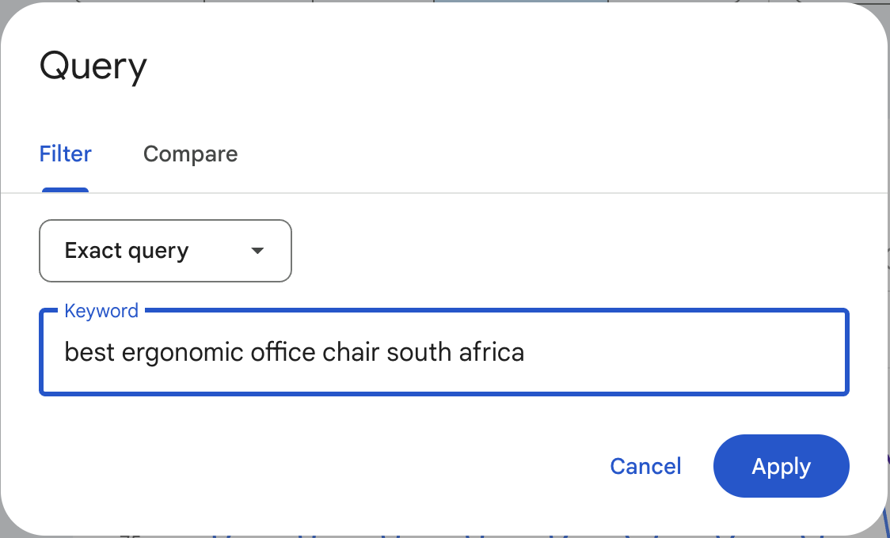

You will be presented with the clicks, impressions, average CTR and average position.

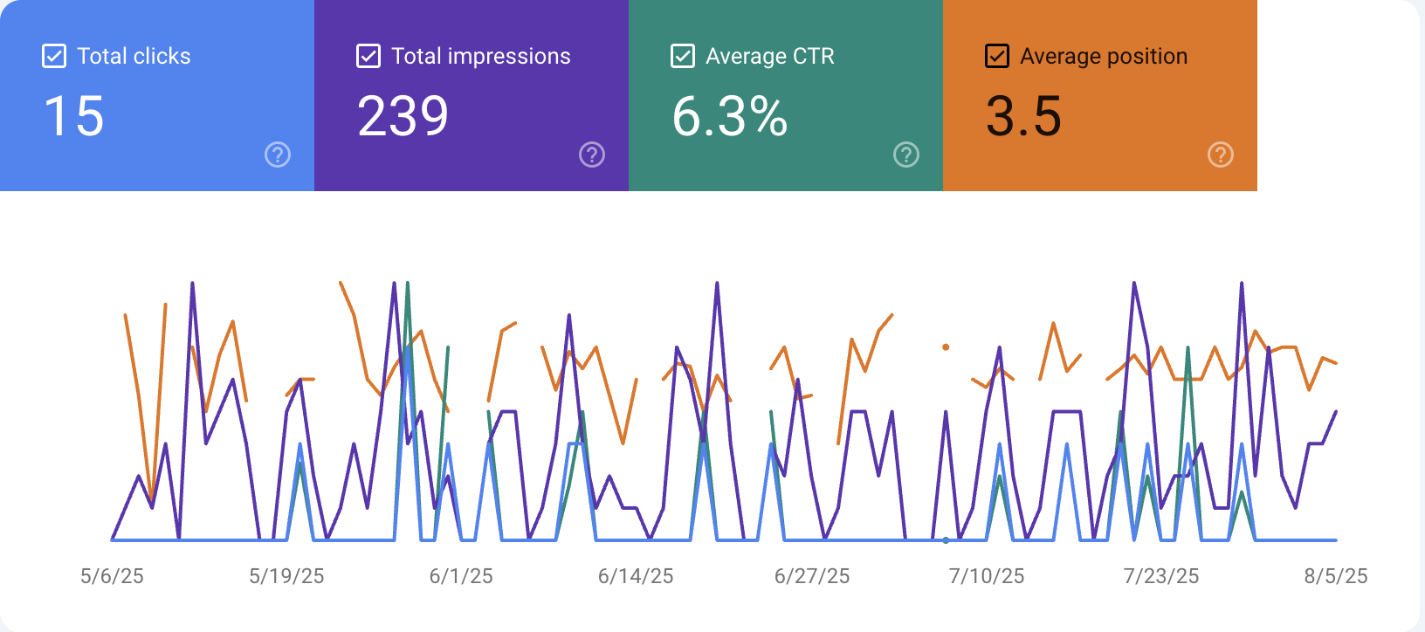

Populate the columns with the data.

Navigate to “pages” in GSC and copy the top-performing URL. Paste it into the sheet.

Prioritising Your Topics Based on Their Ahrefs Metrics

Step 1: Confirm Search Intent Alignment
- Ensure the top-ranking results match the format and purpose of the content you plan to create (e.g. blog post, product page, guide).
- If the intent doesn’t match, either reframe the keyword targeting (choose a variation with better-aligned intent) or adjust the content type to match what the SERP is favouring. If neither is viable, deprioritise the topic.

Step 2: Assess Business Relevance
Consider how directly the keyword supports your core products, services, or commercial objectives.
- Consider each keyword in relation to its stage in the buyer journey, for example, TOFU (awareness), MOFU (consideration), BOFU (decision), or Evergreen (always-relevant informational content).
- Consider how naturally the topic supports lead generation, sales enablement, or brand authority.
- Prioritise:
  - BOFU keywords with clear commercial or transactional intent
  - Evergreen topics that can drive sustained traffic and support internal linking
  - MOFU keywords, if they can bridge cluster content to conversion pages
- Deprioritise keywords with weak, broad or tangential business alignment—even if they have high search volume—unless they serve a strategic purpose (e.g. thought leadership or top-funnel brand awareness).

Step 3: Interpret Traffic Potential
Use the recorded traffic potential value to assess the likely visibility and upside of ranking for this keyword.
- A high traffic potential indicates that the top-ranking page is capturing traffic from many related keywords, not just the exact match/primary keyword focus.
This suggests an opportunity to:
  - Rank for multiple keyword variations, synonyms, and semantically related queries
  - Capture a broader audience beyond the primary keyword alone
  - A comprehensive, well-structured resource (e.g. a guide, listicle, or tutorial) that satisfies multiple variations of a search intent
- Low traffic potential may indicate limited organic visibility or overly narrow targeting.
  - If the keyword has high intent or commercial value, it may still be worth prioritising despite low traffic potential.
  - If the keyword is top-of-funnel with low TP, consider deprioritising or folding it into broader content.

Step 4: Cross-Check Monthly Search Volume
Monthly search volume shows how often your exact target keyword is searched per month — it's a useful indicator of direct demand.
Use it to help:
- Validate that there’s enough standalone interest in the exact phrasing you’re targeting
- Compare against traffic potential to better understand the breadth or narrowness of opportunity.

How to interpret the relationship between search volume and traffic potential:
- High monthly search volume + low traffic potential
  - The keyword itself is popular, but the top-ranking page isn’t attracting much traffic overall.
Possible reasons:
  - Narrow intent — a few long-tail or related terms contribute to additional traffic. In this case, treat with caution. You’ll need to either stand out in the SERP or consider if there’s a better variation to target.
  - Low click-through rate (e.g. due to SERP features like featured snippets or ads)
- Low monthly search volume + high traffic potential
  - The keyword is not heavily searched in exact-match form, but the top-ranking page is attracting lots of traffic from other related keywords.
  - This suggests the topic has strong expansion potential and is worth targeting, especially for guides or long-form informational content.
Bottom line: Monthly search volume confirms how popular the query is in isolation, while traffic potential shows how valuable it is as a gateway to a broader topic.

Step 5: Evaluate Keyword Difficulty
- Review the Keyword Difficulty (KD) score for the keyword and parent topic.
- Use this to estimate how competitive the keyword is, but don’t let it override business or content potential.
- Consider your domain’s authority when interpreting KD—high KD might be viable for strong domains.

Step 6: Analyse SERP Competitiveness
- Look beyond KD. Manually check the Domain Ratings (DR), backlink profiles, and content quality of the top 5–10 results.
- Consider opportunities where high-ranking content is outdated, thin, or low authority.
- Identify any aggregator or user-generated content (e.g. Quora, Reddit) as a potential vulnerability to target.

Step 7: Estimate Content Effort
- Review the average word count and content type required to compete.
- Factor in additional effort such as original research, SME input, visuals, or technical explanations.
- Weigh effort against potential reward (traffic, leads, authority).

Step 8: Consider Topical Fit and Internal Value
- Check if the topic fits into an existing content hub or supports internal linking.
- Identify opportunities to reinforce or expand a content cluster.
- Downgrade isolated topics unless they serve a strategic campaign or offer exceptional value.

Step 9: Assign Final Priority
- Use a combination of all the above data points to assign High, Medium, or Low priority in the strategy template.
- Ensure your reasoning is documented, especially when going against the grain (e.g. prioritising low-volume terms for strategic reasons).

Step 10: Validate with a Peer Review
- Assign the topic for internal review to ensure data accuracy and that your prioritisation aligns with broader SEO and business strategy.
- Finalise before moving the topic into production.

Prioritisation summary framework
Priority Level | Criteria
High | High traffic potential, clear intent match, and strong business relevance. Monthly search volume supports demand. SERPs are beatable or underserved. Keyword difficulty and content effort are acceptable.
Medium | Moderate traffic potential or moderate monthly search volume. Content is relevant but not central to the funnel. May face moderate SERP competition or require more effort. Worth considering for future publication.
Low | Low traffic potential and low monthly search volume. Weak alignment with intent or business goals. High effort required or not part of any key topical cluster. Can be deprioritised or parked.

Supporting Content & Delivery Status

Copy and paste links to related blog posts and landing pages for each topic.
Remember, it’s not essential to link to every blog and landing page; just link to the most relevant ones.

For example, if a topic is about the best wine tastings in Cape Town, relevant blog posts to link to could be based on the subject “wine tastings” or the region “Cape Town” (or the Western Cape/possibly South Africa).

Ask for Your Topics to be Reviewed/Request a Review of Your Topics
Assign a task to the peer reviewer to assess the topics you’ve suggested and the data you’ve collected.

The peer reviewer will verify that all of your data is accurate and that each topic suggested aligns with search intent and is relevant to the project's or client's goals.

How to Find Content Ideas
Please refer to this resource to help you generate/formulate content ideas.
Content Idea Generation

